

LICENSURE EXAMINATION FOR PROFESSIONAL TEACHERS
SEPTEMBER 20, 2026

GURONG PINOY: GENERAL EDUCATION REVIEWER
SCIENCE & LANGUAGE REFRESHER
(Session 7: May 13, 2026)

1. “Scent of Apples,” a collection of stories that succeeded with the United States audience, was written by ___.
- Bienvenido Santos
- Jose Garcia Villa
- F. Sionil Jose
- Carlos Bulosan

Option | Author | Pen Names / Monikers | Key Masterworks | Why Correct / Incorrect for this Item?
a) | Bienvenido Santos | "Father of Filipino-American Migrant Literature"  Nicknamed "Ben" | "Scent of Apples"  "The Day the Dancers Came" | Correct. He wrote "Scent of Apples" (1979), which won the American Book Award and captured the exile of early Filipino migrants.
b) | Jose Garcia Villa | "Doveglion" (Dove, Eagle, Lion)  Pseudonym "O. Sevilleja" | “Have Come, Am Here”  “Footnote to Youth” | Incorrect. He is a renowned avant-garde poet famous for introducing "comma poems" and "reversed consonance" rhyme schemes.
c) | F. Sionil Jose | Nicknamed "Frankie" | Rosales Saga (Po-on, The Pretenders, Mass) | Incorrect. He wrote the five-novel epic saga detailing generational social struggles and class divisions within Philippine history.
d) | Carlos Bulosan | Nicknamed "Allos" | “America Is in the Heart”  “The Laughter of My Father” | Incorrect. He wrote the defining semi-autobiographical novel exposing labor exploitation and racism against West Coast migrants.

2. William Sydney Porter was a famous American writer of short stories noted for surprise endings like the Gift of the Magi, Cabbages and Kings, The Last Leaf in which he used the pen name
- Mark Twain
- George Eliot
- Longfellow
- O. Henry

Option | Author | Pen Names / Monikers | Key Masterworks | Why Correct / Incorrect for this Item?
a) | Samuel Langhorne Clemens | Mark Twain  "Father of American Literature" | The Adventures of Tom Sawyer  Adventures of Huckleberry Finn | Incorrect. He is a renowned American humorist and satirist. His pen name "Mark Twain" is a riverboat pilot term meaning "two fathoms deep."
b) | Mary Ann Evans | George Eliot | Silas Marner  Middlemarch | Incorrect. She was an English novelist who used a male pen name to ensure her serious works were taken seriously by Victorian society.
c) | Henry Wadsworth Longfellow | No major pen name (published under his real name)  One of the Fireside Poets | The Song of Hiawatha  Paul Revere's Ride | Incorrect. Longfellow is a celebrated 19th-century American poet, not a short story writer noted for surprise endings.
d) | William Sydney Porter | O. Henry  Olivier Henry | "The Gift of the Magi"  "The Last Leaf"  Cabbages and Kings | Correct. He adopted the pen name O. Henry (allegedly derived from a prison guard's name or a family cat) while serving time for embezzlement. He is famous for his signature twist/surprise endings.

3. In a food chain, if cows are primary consumers of grass, then the secondary consumers are humans who are ______.
- detritivores
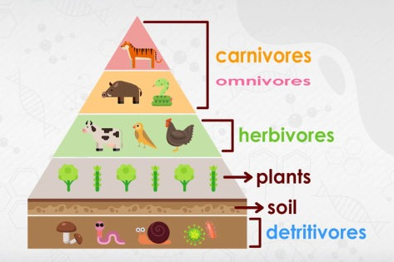
- carnivores
- omnivores
- herbivore
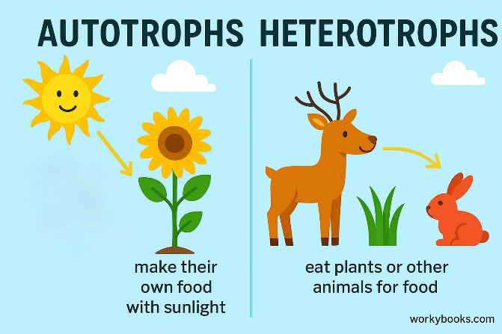

Consumer Types
Consumer Type | Primary Diet / Food Source | Ecological Role / Mechanism | Key Examples
Herbivore | • Only plants / producers | • Primary consumers in the food chain | • Cows, caterpillars, deer, grasshoppers
Carnivore | • Only animals / meat | • Secondary or tertiary consumers; predators or scavengers | • Lions, eagles, sharks, frogs
Omnivore | • Both plants and animals | • Adaptable feeding; can occupy multiple trophic levels | • Humans, bears, pigs, crows
Decomposer | • Dead organic matter | • Extracellular digestion: Secretes enzymes outside the body to break down and absorb nutrients | • Fungi, bacteria
Detritivore | • Dead organic matter (Detritus) | • Internal digestion: Physically ingests, chews, and digests dead matter internally | • Millipedes, earthworms, woodlice
Specialist | • Only one specific organism | • Highly sensitive to environmental changes; narrow niche | • Koalas (eucalyptus), Pandas (bamboo)
Generalist | • Wide variety of organisms | • Highly adaptable to changing environments; broad niche | • Raccoons, rats, coyotes, humans

Decomposer vs. Detritivore
Feature | Decomposer (Saprotroph) | Detritivore
Digestion Method | • External / Extracellular (releases enzymes onto dead matter, liquefies it, then absorbs it) | • Internal (physically eats, ingests, and digests the dead matter inside its gut)
Physical Form | • Microscopic or non-motile structures | • Macro-organisms with mouths and digestive tracts
The Nutrient Cycle | • Ultimate Recyclers: Breaks matter down into molecular nutrients that go straight back to producers | • Fragmenters: Breaks large dead matter into smaller pieces, making it easier for decomposers to work
Key Examples | • Fungi, Mold, Bacteria | • Millipedes, Earthworms, Crabs, Slugs

Specialist vs. Generalist
Feature | Specialist | Generalist
Diet Range | • Extremely narrow (only 1 food source) | • Broad and varied
Niche Size | • Narrow ecological niche | • Broad ecological niche
Extinction Risk | • High (if their single food source dies, they die) | • Low (if one food source disappears, they switch to another)
Competition | • Low competition for their specific food | • High competition with many other species

4. Potential energy is to battery, as a moving electric fan is to ___ energy.
- nuclear
- mechanical
- chemical
- kinetic
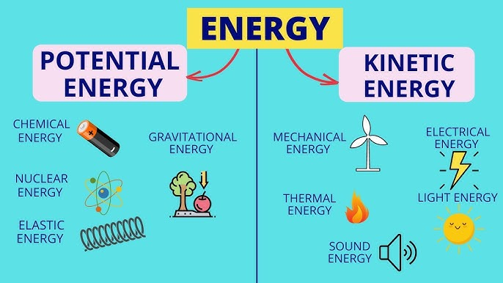

Visual Chart Breakdown
Energy Category | Sub-Type | Visual Anchor in Image | Real-World Application
Potential Energy  (Stored Energy) | Chemical | Household Battery | Stored atomic bonds ready for electrical discharge.
 | Nuclear | Atomic Nucleus / Orbitals | Energy stored in the bonds of subatomic particles.
 | Elastic | Compressed Metal Spring | Energy held by a physically deformed object.
 | Gravitational | Apple Falling from Tree | Position-based energy caused by Earth's gravity.
Kinetic Energy  (Motion Energy) | Mechanical | Wind Turbine | Physical movement of large, structural objects.
 | Thermal | Open Flame / Fire | Chaotic, rapid movement of microscopic molecules.
 | Sound | Audio Speaker Waves | Pressure waves vibrating through a physical medium.
 | Electrical | Lightning Bolt Symbol | Directed flow of electrons through a pathway.
 | Light | Radiant Sun | Electromagnetic radiation moving across open space.

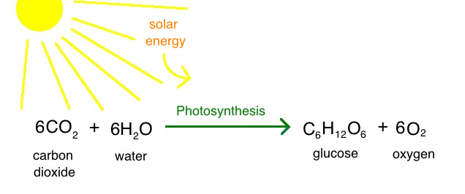
5. What gas do plants absorb?
- Oxygen
- Carbon dioxide
- Nitrogen
- Hydrogen

6. The major source of energy on earth is the ___.
- Wind
- Forest
- Ocean
- Sun

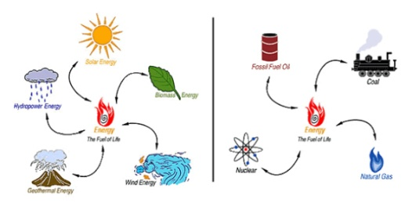
7. Which of the following is a renewable energy source?
- Coal
- Natural gas
- Solar power
- Crude oil

Energy Category | Specific Source | Functional Mechanism | Core Characteristic
Renewable  (Naturally replenishes quickly; impossible to deplete through human use.) | Solar | Captured from sunlight using photovoltaic panels. | Inexhaustible daily supply.
 | Wind | Generated by atmospheric air currents spinning turbines. | Driven by atmospheric heat.
 | Hydroelectric | Harvested from the gravitational flow of moving water. | Uses natural water cycles.
 | Geothermal | Tapped from natural heat fields deep inside Earth's crust. | Constant underground heat.
 | Biomass | Derived from organic plant matter and animal waste. | Plant-based carbon cycle.
Non-Renewable  (Exists in fixed, finite amounts; takes millions of years to form.) | Fossil Fuels | Includes coal, crude oil (petroleum), and natural gas. | Formed via geological pressure.
 | Nuclear Fuel | Uranium ore mined directly from crustal rock deposits. | Finite mineral resource.

8. Which poem form traditionally consists of 14 lines and a specific rhyme scheme?
- Haiku
- Limerick
- Sonnet
- Free verse

Poetic Form | Memory Hook | Quick Formula | Core Mental Picture
Sonnet | Fourteen & Flip | 14 lines total | A long poem with a surprise twist.
Tanka | Longer Haiku | 5 lines (5-7-5-7-7) | Nature image turning into an emotion.
Haiku | Nature Snapshot | 3 lines (5-7-5) | A brief picture of a season.
Limerick | AABBA Joke, humorous poem | 5 lines (Rhyme: 1=2=5) | A funny, bouncy short story.
Free Verse | Total Freedom | No fixed formula | Words written with zero rules.

9. Which of the following sentences about the greenhouse effect is INCORRECT?
- Greenhouse gases trap heat in the atmosphere which is returned to the earth’s surface.
- Greenhouse effect is due to gases that absorb the green region of light from the sun.
- Greenhouse effect is important in maintaining the temperature of the earth.
- Greenhouse effect increases the overall surface temperature of the earth.
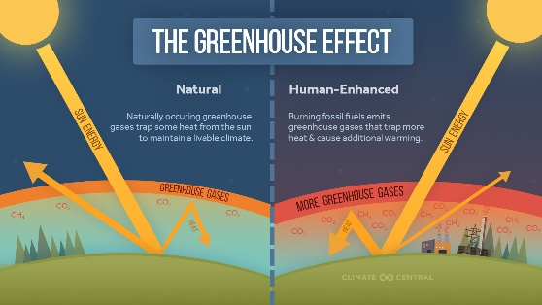

10. It shows the complex food relationship of organism in a given area and the cyclic flow of food through organisms
- Food chain
- Food web
- Food pyramid
- Biological cycle

Option | Concept | Key Structural Feature | Memory Hook
A | Food chain | Linear, single pathway | Straight Line (One way only)
B | Food web | Interconnected, multi-pathway network | Messy Network (All connected)
C | Food pyramid | Quantified biomass/energy tiers | Trophic Stack (Loss at each step)
D | Biological cycle | Nutrient/element recycling processes | Chemical Loop (Water/Carbon recycling)

11. Alin ang wastong paggamit ng tutuldok?
- Dalhin mo ang mga ito, lapis, papel at libro.
- Dalhin mo ang mga ito; lapis, papel at libro.
- Dalhin mo ang mga ito: lapis, papel, at libro.
- Dalhin mo ang mga ito lapis, papel at libro.

English Name | Bantas sa Filipino | Simbolo | Memory Hook / Pangunahing Gamit | Halimbawa (Example)
Period | Tuldok | . | Katapusan o Daglat  Ginagamit sa dulo ng pahayag o sa pinaikling salita. | Siya ay guro.  Gng. Santos
Comma | Kuwit | , | Hinto o Listahan  Ginagamit para sa panandaliang hinto o pag-iisa-isa. | Bumili ng saging, mansanas, at ubas.
Question Mark | Tandang Pananong | ? | Pagtatanong  Ginagamit sa hulihan ng tanong. | Sino ang kasama mo?
Exclamation Point | Tandang Padamdam | ! | Matinding Emosyon  Ginagamit kapag nagulat, natakot, o natuwa. | Naku! Nahulog ang bata.
Colon | Tutuldok | : | Listahan o Liham  Nagpapakilala ng listahan o serye. | Dalhin ang mga ito: papel at panulat.
Semicolon | Tuldok-Kuwit | ; | Kalahating Hinto  Nagdurugtong ng dalawang magkaibang kaisipan. | Mag-aral ka mabuti; malapit na ang LET.
Hyphen | Gitling | - | Pag-uulit o Tambalan  Pinagdurugtong ang mga salitang inuulit. | Araw-araw  Taktak-bata
Apostrophe | Kudlit | ' | Nawalang Titik  Pamalit sa nawawalang letra sa salita. | Siya't ikaw (Siya at ikaw)
Quotation Marks | Panipi | “ ” | Sinabi o Pamagat  Ginagamit sa tuwirang sinabi ng tao. | Sinabi niya, “Mag-aral ka.”
Parentheses | Panaklong | ( ) | Dagdag Impormasyon  Pantulong na paliwanag sa loob ng pangungusap. | Si Dr. Jose Rizal (ang bayani) ay matalino.

- Liham Pangkaibigan vs. Liham Pangangalakal:
- Gumagamit ng Kuwit (,) sa bating panimula ng liham-pangkaibigan (Halimbawa: Mahal kong Ina,).
- Gumagamit ng Tutuldok (:) sa bating panimula ng liham-pangangalakal o business letter (Halimbawa: Kagalang-galang na Tagapamahala:).

- Gitling (-): Madalas itanong kung kailan ginagamit. Lagi itong ginagamit kapag ang panlapi ay nagtatapos sa katinig at ang salitang-ugat ay nagsisimula sa patinig (Halimbawa: mag-aaral, pang-ulam).

12. Ano ang pangunahing layunin ng editoryal?
- Magbigay ng opinyon
- Magbigay ng balita
- Magbenta ng produkto
- Maglarawan ng pangyayari

Mga Bahagi ng Pahayagan (Parts of a Newspaper)
English Name | Tagalog Name | Main Purpose / Gamit (Key Words) | Detalyadong Layunin (Detailed Use)
General News  (Front Page) | Pangulong Pahina  (Unang Pahina) | Mukha at Pangunahing Balita | Dito nakikita ang pinakamahahalagang balita sa loob at labas ng bansa, pangalan ng diyaryo, at ang pangunahing ulo ng balita (headline).
Editorial Page | Pahinang Editoryal / Pangulong tudling | Kuru-kuro at Opinyon | Dito mababasa ang personal na opinyon, pananaw, o kaisipan ng editor o pamunuan ng pahayagan ukol sa isang mainit na isyu. Naglalaman din ito ng editorial cartoon.
Local News | Balitang Lokal | Balitang Pambansa | Nakapokus sa mga kaganapan, batas, krimen, o pangyayari na nagaganap sa loob mismo ng sariling bansa o komunidad.
Foreign News | Balitang Pandaigdig | Balitang Internasyonal | Naglalaman ng mga ulat at mahahalagang pangyayari mula sa iba't ibang bansa sa buong mundo.
Business & Finance | Balitang Komersyo / Kalakalan | Negosyo at Ekonomiya | Nag-uulat tungkol sa takbo ng stock market, palitan ng piso kontra dolyar, presyo ng bilihin, at iba pang usaping pang-ekonomiya.
Sports Page | Pahinang Palakasan | Isport at Atletiko | Naglalaman ng mga resulta ng laro, iskedyul ng torneo, tsismis sa sports, at profile ng mga sikat na atleta.
Entertainment & Society | Pahinang Libangan / Aliwan | Artista, Pelikula, at Tsismis | Dito makikita ang tungkol sa mga palabas sa telebisyon, pelikula, sikat na personalidad, teatro, krosword (crossword), at horoskopo.
Classified Ads | Anunsyo Klasipikado | Hanapbuhay, Bahay, at Benta | Dito nagbabayad ang mga tao upang mag-anunsyo ng paghahanap ng trabaho, pagbebenta ng kotse, pagpapaupa ng bahay, o mga serbisyong legal.
Obituary | Obitwaryo / Anunsyo ng Pagpanaw | Patalastas ng Kamatayan | Nagsisilbing anunsyo para sa mga taong pumanaw na, kung kailan at saan ang kanilang burol, at detalye ng libing.
Lifestyle | Estilo ng Pamumuhay | Pagkain, Moda, at Paglalakbay | Naglalaman ng mga artikulo tungkol sa tamang nutrisyon, bagong uso sa pananamit (fashion), mga tips sa pagluluto, at mga lugar na magandang pasyalan.

- Headline (Ulo ng Balita): Ang pamagat ng pinakamalaking balita na nakasulat sa malalaking titik sa unang pahina upang madaling makakuha ng pansin.

- Byline: Ang pangalan ng reporter o manunulat na nagsulat ng partikular na artikulo (makikita sa ilalim ng pamagat).

- Dateline: Nagpapakita kung kailan isinulat ang balita at kung saan ito naganap o nagmula.

13. Which biome has the highest biodiversity?
  - Desert
  - Tundra
  - Tropical rainforest
  - Grassland

A
biome is a distinct geographical region with specific climate, vegetation (flora), animal life (fauna), and an ecosystem.

Terrestrial Biomes (Land Ecosystems)
Biome Name | Climate Pattern | Key Flora & Fauna | Core Exam Memory Hook
Tropical Rainforest | Warm + High Rain | Canopy trees, vines, jaguars | Highest Biodiversity
Desert | Extreme Heat + Dry | Cacti, camels, nocturnal reptiles | Zero Water / Arid
Tundra | Extreme Cold + Dry | Mosses, lichens, arctic foxes | Frozen Permafrost Soil
Taiga (Boreal Forest) | Cold + Snowy winters | Coniferous / Pine trees, moose | Cone-bearing Trees
Temperate Deciduous Forest | 4 Distinct Seasons | Oak, maple, deer, squirrels | Leaves Change Color / Fall
Grassland (Savanna/Prairie) | Seasonal rain + Fires | Grasses, lions, zebras, bison | Treeless Open Plains
Chaparral (Shrubland) | Hot, dry summers + Mild wet winters | Thorny shrubs, coyotes | Frequent Wildfires

Aquatic Biomes (Water Ecosystems)
Biome Name | Salinity / Water Type | Key Regions / Examples | Core Exam Memory Hook
Marine (Ocean) | High Salt | Coral reefs, deep ocean vents | Largest Global Biome
Freshwater | Low/No Salt | Lakes, rivers, ponds, streams | Drinking Water Sources
Estuary | Mixed / Brackish Water | River mouths, mangrove swamps | Where River Meets Sea
Wetlands | Saturated Soil | Swamps, bogs, marshes | Natural Water Filters

Global Biome Records (Largest vs. Smallest Boundaries)
Biome Type | Extreme Class | Official Geographical Name | Exact Location | Primary Exam Distinction
Tropical Rainforest | Largest | Amazon Rainforest | South America (mostly Brazil) | Holds 40% of global rainforest area.
 | Smallest | Daintree Rainforest | Queensland, Australia | Oldest continuously surviving jungle.
Desert | Largest | Antarctic Desert | South Pole / Antarctica | Largest overall desert (cold desert).
 | Largest Hot | Sahara Desert | Northern Africa | Largest hot and sandy desert ecosystem.
 | Smallest | Carcross Desert | Yukon, Canada | Smallest arid sand patch in the world.
Tundra | Largest | Arctic Tundra | Northern Russia, Canada, Alaska | Continuous ring around North Pole.
 | Smallest | Alpine Tundra Zones | Mount Kilimanjaro (Peak), Africa | Isolated to high-altitude mountain caps.
Taiga (Boreal) | Largest | Siberian Taiga | Russia (Siberia region) | World's largest forest ecosystem.
 | Smallest | High-Latitude Transition Belts | Southern Border of Canada | Narrow forest line shrinking into prairies.
Grassland | Largest | Eurasian Steppe | Central Asia (Ukraine to China) | Flat, unbroken grass highway.
 | Smallest | Puszta Grasslands | Hungary | Fragmented pocket of protected plains.
Marine (Ocean) | Largest | Pacific Ocean | Global (Western Hemisphere) | Largest total biome on the planet.
 | Smallest | Red Sea / Baltics | Middle East / Northern Europe | Highly isolated marine gulf borders.

14. The largest biome on Earth is
- Desert
- Grassland
- Marine
- Tundra

15. Ang tunog na walang harang ay tinatawag na
- Katinig
- Pantig
- Diptonggo
- Patinig

Option | Konsepto | Paraan ng Pagbigkas (Mechanism) | Memory Hook / Keyword
A | Katinig | May harang o sagabal sa hangin dulot ng labi, ngipin, o dila. | May Harang (B, D, K, S...)
B | Pantig | Saltik ng dila o isang walang lagot na bugso ng tinig sa pagbigkas ng salita. | Yunit ng Salita (Ba-ta)
C | Diptonggo | Pagsasama ng isang patinig at isang malapatinig na /w/ o /y/ sa isang pantig. | Kambal-Tunog (aw, ay, oy...)
D | Patinig | Ang hangin mula sa baga ay lumalabas nang walang harang sa bibig. | Walang Harang (A, E, I, O, U)

- Ponema (Phoneme): Ang pinakamaliit na yunit ng makabuluhang tunog sa isang wika.
- Klaster (Kambal-Katinig): Dalawang magkaibang katinig na magkasama sa isang pantig (Halimbawa: Pl-ato, Tr-ako).
- Glottal Stop (Impit na Tunog): Isang uri ng katinig na nalilikha sa pamamagitan ng pagsasara ng glottis (Halimbawa: bag-ang na may bitiw sa dulo).

16. What is the antonym of scarce?
- Plentiful
- Limited
- Rare
- Few

- antonyms – opposite meaning
- synonyms – the same meaning

LET Synonyms (Same Meaning)
High-Frequency Word | Synonym (Same Meaning) | Meaning / Context | LET Exam Memory Hook
Altruistic | Unselfish / Philanthropic | Caring for others without reward. | ALtruistic = ALways helping
Ambiguous | Vague / Unclear | Having more than one meaning. | AMBI (both) = unclear path
Candid | Honest / Frank | Outspoken and completely open. | CANDID camera = real & raw
Ephemeral | Short-lived / Transient | Lasting for a very brief time. | E-PHENOMENAL = gone fast
Frugal | Thrifty / Economical | Wise and careful with money. | FRUGAL = eating cheap fruit
Lethargic | Sluggish / Drowsy | Lacking energy or alertness. | LETHARGIC = lazy log
Meticulous | Careful / Scrupulous | Showing extreme care about details. | METICULOUS = making exact edits
Prudent | Wise / Cautious | Showing good financial judgment. | PRUDENT = preparing properly
Superficial | Shallow / Surface-level | On the surface; not deep. | SUPERFICIAL = surface view
Venerable | Respected / Honored | Accorded a great deal of respect. | VENERABLE = very old & wise

LET Antonyms (Opposite Meaning)
High-Frequency Word | Antonym (Opposite Meaning) | Meaning of Word | LET Exam Memory Hook
Affluent | Poor / Imposed | Wealthy and rich. | Affluent = A-lot of money
Belligerent | Peaceful / Friendly | Aggressive and ready to fight. | BELLigerent = ringing combat bell
Complacent | Anxious / Ambitious | Self-satisfied and unconcerned. | COMPLACENT = too comfortable
Garrulous | Silent / Taciturn | Excessively talkative. | GARRULOUS = gabbing non-stop
Homogeneous | Heterogeneous | All of the same kind. | HOMO = same kind
Indigenous | Foreign / Alien | Native to a specific area. | INdigenous = born IN the land
Nadir | Zenith / Peak | The lowest point of adversity. | NADIR = near the ground
Obsolete | Modern / Current | Outdated; no longer in use. | OBSOLETE = old system
Spurious | Authentic / Genuine | Fake, false, or counterfeit. | SPURIOUS = suspect story
Volatile | Stable / Constant | Highly unstable or explosive. | VOLATILE = violently changing

17. Ano ang pang-uri sa pangungusap: "Maganda ang tanawin sa bundok."
- tanawin
- bundok
- maganda
- ang

Parts of Speech (Mga Bahagi ng Pananalita)
Tagalog Term | English Match | LET Exam Memory Hook | Simple Definition | Core Test Example
Pangngalan | Noun | Pangalan / Name | Name of a person, place, thing, or event. | Juan, Maynila, guro  (Teacher, Manila)
Panghalip | Pronoun | Pamalit / Substitute | Replaces a noun to avoid repetition. | Ako, siya, tayo, ito  (I, he, we, this)
Pandiwa | Verb | Kilos / Action | Expresses action, movement, or state of being. | Tumakbo, kumakain, nag-aral  (Ran, eating, studied)
Pang-uri | Adjective | Naglalarawan ng Noun | Describes or modifies a noun or a pronoun. | Maganda, matalino, mabilis  (Beautiful, smart, fast)
Pang-abay | Adverb | Naglalarawan ng Kilos | Modifies a verb, adjective, or another adverb. | Dahan-dahan, kahapon, tunay  (Slowly, yesterday, truly)
Pangatnig | Conjunction | Pang-dugtong / Bridge | Joins words, phrases, or clauses together. | At, ngunit, dahil, sapagkat  (And, but, because)
Pang-ukol | Preposition | Ugnayan / Position | Shows the location, time, or direction relationship. | Para sa, ayon kay, sa ibabaw  (For, according to, on top)
Pandamdam | Interjection | Damdamin / Emotion | Expresses sudden, strong feelings or reactions. | Aray!, Wow!, Naku!  (Ouch!, Wow!, Oh no!)

18. Alin ang halimbawa ng pang-abay na pamaraan?
- kahapon
- mabilis
- dito
- dahan-dahan

Uri ng Pang-abay (Types of Adverb)
Uri ng Pang-abay | English Adverb Equivalent | Question Hook | High-Yield Exam Examples
1. Pamaraan | Adverb of Manner | Paano? (How?) | Dahan-dahan, patagong, bigla, pabulong
2. Pamanahon | Adverb of Time | Kailan? (When?) | Kahapon, kanina, bukas, noong Lunes
3. Panlunan | Adverb of Place | Saan? (Where?) | Sa paaralan, dito, doon, sa ibabaw
4. Pang-agam | Adverb of Doubt | Sure ba? (Certainty) | Tila, baka, siguro, tila-waring
5. Panang-ayon | Adverb of Affirmation | Yes? (Agreement) | Oo, opo, talaga, tunay, siyanga
6. Pananggi | Adverb of Negation | No? (Disagreement) | Hindi, huwag, ayaw

19. Ano ang wastong gamit ng “nang”?
- Bumili siya nang mansanas.
- Kumain siya nang mabilis.
- Nang bahay ay malinis.
- Nang siya ay masaya.

Ang Mabilisang Gabay: Kailan Gagamitin ang "Nang" at "Ng"
Tamang Bantas | Paano Itatanong sa Sarili | Pangunahing Batas / Gamit | Halimbawa sa Pangungusap
NANG | Paano ginawa? | Naglalarawan sa kilos (sinasagot ang Paano?). | Patagong umalis nang mabilis.
 | Paulit-ulit ba? | Inilalagay sa pagitan ng mga salitang inuulit. | Sigaw nang sigaw ang bata.
 | Kailan nangyari? | Pamalit sa salitang "noong" | Nang dumating siya, umulan.
 | Para saan ang layunin? | Pamalit sa salitang "upang" o "para". | Magbasa ka nang matuto ka.
NG | Ano ang ginawa/binili? | Sinasagot ang tanong na Ano? (Tiyak na bagay). | Kumuha siya ng pambura.

20. What is the powerhouse of the cell?
- Nucleus
- Ribosome
- Mitochondria
- Cell membrane

This question assesses basic understanding of Cytology (the study of cells) and the analogies commonly used to identify primary organelle functions.
Option | Organelle Name | Primary Cellular Function | LET Board Exam Memory Hook
a) | Nucleus | Stores DNA and manages cell actions. | Command Center / Brain
b) | Ribosome | Synthesizes structural proteins. | Protein Factory
c) | Mitochondria | Generates energy via ATP production. | Powerhouse of the Cell
d) | Cell membrane | Regulates entry and exit of molecules. | Gatekeeper / Security Guard

Core Cellular Organelles: Memory Sheet
Organelle Name | Core Mechanism | Main Exam Distinction
Lysosome | Contains strong digestive enzymes. | Suicide Bag / Garbage Disposer
Golgi Body | Sorts, packs, and ships proteins. | Post Office / Shipping Yard
Chloroplast | Converts sunlight into sugars. | Solar Panels (Plants only)
Vacuole | Stores large volumes of water/waste. | Storage Tank / Warehouse

21. Identify the figure of speech: "Time is a thief."
- Simile
- Metaphor
- Personification
- Hyperbole

Figures of Speech Master Sheet
Figure of Speech | Core Action / Meaning | LET Exam Memory Hook | Clear Test Example
Simile | Compares two things using "like" or "as". | Uses "Like" / "As" | She is as sweet as sugar.
Metaphor | Compares two things directly without "like" or "as". | Direct Match / "Is" | He is a shining star in class.
Personification | Gives human traits or actions to non-human objects. | Human Action to Object | The stubborn wind whispered secrets.
Hyperbole | Uses extreme, impossible exaggeration to make a point. | Over the Top / Drama | I have a million things to do today.
Onomatopoeia | Uses words that copy the actual sound they describe. | Sound Effect Words | The loud clock ticks in the dark.
Apostrophe | Talks directly to an absent person, dead person, or idea. | Talking to the Air | O Liberty, what crimes are done in thee!
Oxymoron | Puts two completely opposite words side-by-side. | Opposites Together | There was a deafening silence inside.
Alliteration | Repeats the same starting consonant sound in a row. | First Sound Repeats | Peter Piper picked a peck of peppers.
Synecdoche | Uses a small part of something to mean the whole thing. | Part Equals Whole | The captain needs more hands on deck.
Irony | Saying the opposite of what you mean to mock or tease. | Sarcasm / Twisted Meaning | What clean shoes! (looking at muddy boots)

22. Choose the correct sentence.
  - Neither of the students are ready.
  - Neither of the students is ready.
  - Neither of the students were ready.
  - Neither of the students have ready.

Subject-Verb Agreement Master Cheat Sheet
Category | High-Yield Pronoun List | Quick Formula | Core Elimination Trick | Clear Test Example
Always Singular | Each, Every, Either, Neither, Everyone, Anyone, Someone, No one, Nobody | Pronoun + [of the plural nouns] = Singular Verb (is/was/has/verb+s) | Cross-Out Strategy:  Draw a line through the plural phrase. Read it as: "Neither [___] ready." Your brain will instantly select is. | • Neither [of the students] is ready.  • Each [of the players] scores a point.
Always Plural | Both, Few, Many, Several | Pronoun + [plural nouns] = Plural Verb (are/were/have/base verb) | Multiple Count:  These always mean more than one. Look for verbs without an "s" at the end. | • Both [of the items] are ready.  • Several [of the books] were lost.
The "SAMAN" Split  (Variable) | Some, All, Most, Any, None | Look at the noun after "of the" to decide the verb. | Mass vs. Count:  If you can count the item, use plural. If you can't count it (liquids/abstracts), use singular. | • All of the milk is spilled. (Uncountable)  • All of the apples are ripe. (Countable)
The Proximity Rule  (Closer Subject Wins) | Neither... nor  Either... or  Not only... but also | [Subject 1] + nor/or + [Subject 2] = Verb matches Subject 2. | Blindfold Test:  Cover Subject 1 and the connector word with your hand. Match the verb strictly to what is left. | • Neither the teacher nor the students are ready.  • Neither the students nor the teacher is ready.

23. Ano ang tayutay sa pangungusap na: "Ang buhay ay parang gulong."
- Simili
- Metapora
- Personipikasyon
- Pagmamalabis

Klase ng Tayutay (Figures of Speech)
Pangalan ng Tayutay | English Name | Kahulugan / Aksyon | Mabilis na Tandaan (Memory Hook) | Malikhaing Halimbawa
1. Pagtutulad | Simile | Di-direktang paghahambing ng dalawang magkaibang bagay. | May Salitang: tila, parang, gaya ng, kawangis, magkasing- | Ang puso mo ay gaya ng bato.
2. Pagwawangis | Metaphor | Direktang paghahambing na tila ba ang isa ay mismong ang ikalawa. | Walang Salitang Paghahambing  (Direktang sinabi na "ito ay yaon") | Ang puso mo ay bato.
3. Pagsasatao | Personification | Pagbibigay ng katangian, talino, o kilos ng tao sa mga bagay o hayop. | Kilos-Tao sa Bagay | Sumasayaw ang mga dahon sa ihip ng hangin.
4. Pagmamalabis | Hyperbole | Sobrang pagpapasidhi, pagpapalabis, o eksaherasyon sa katotohanan. | Sobrang OA / Imposible | Ulan ng luha ang umagos sa kanyang mga mata.
5. Paghihimig | Onomatopoeia | Paggamit ng mga salita kung saan ang tunog ay nagpapahiwatig ng kahulugan. | Tunog ng Bagay / Hayop | Naririnig ko ang tilaok ng manok.
6. Pagtawag | Apostrophe | Direktang pakikipag-usap sa isang kaisipan, bagay, o taong patay/wala naman. | Kausap ang Hangin  (Madalas may "O...") | O, Tukso! Layuan mo ako.
7. Pagtatambal | Oxymoron | Pagsasama ng dalawang salitang magkasalungat ang kahulugan. | Magkasalungat na Magkatabi | Isang mabuting masamang balita ang aking narinig.
8. Aliterasyon | Alliteration | Pag-uulit ng parehong tunog-katinig sa simula ng mga salita sa isang taludtod. | Unang Letra ay Pare-pareho | Mabilis matuto ang mga mabuting mag-aaral.
9. Pagpapalit-saklaw | Synecdoche | Pagbanggit sa isang bahagi ng bagay upang kumatawan sa kabuuan nito. | Bahagi para sa Kabuuan | Kailangan ko ng apat na mata upang magbantay sa iyo.
10. Pag-uyam | Irony | Pahayag na tila pumupuri ngunit ang tunay na layunin ay mangutya o mang-inis. | Sarkastiko / Pa-plastic | Napakalinaw ng mata mo, hindi mo nga nakita ang dambuhalang trak.
11. Pagpapalit-tawag | Metonymy | Pagpapalit ng ngalan ng isang bagay sa pamamagitan ng pagbanggit sa kaugnay nito. | Simbolo o Relasyon ng Salita | Ang Trono (Hari/Pamahalaan) ay naglabas ng bagong utos.
12. Pagtanggi | Litotes | Paggamit ng salitang "hindi" upang magpahiwatig ng isang positibong pag-amin. | Hindi + Negatibo = Positibo | Siya ay hindi kawalan sa ating grupo. (Ibig sabihin, mahalaga siya)

24. Ano ang uri ng pangungusap na: "Isara mo ang pinto."
- Pasalaysay
- Patanong
- Pautos
- Padamdam

Sentences According to Use (Ayon sa Gamit)
Sentence Type | English Match | Functional Use | Quick Formula | Exam Examples
1. Pasalaysay  (Declarative) | Statement | Tells a fact, idea, or event. | Subject + Action + Period (.) | Siya ay matalinong guro.  Maganda ang sikat ng araw.
2. Patanong  (Interrogative) | Question | Seeks specific information. | Question Word + Question Mark (?) | Nakapasa ka ba sa LET?  Kailan ang araw ng pagsusulit?
3. Pautos  (Imperative) | Command | Tells or directs someone to do a task. | Command Word + Action + Period (.) | Linisin mo ang iyong kuwarto.  Basahin ninyo ang libro.
4. Pakiusap  (Request) | Polite Request | Asks for a favor gently. Often counted under Pautos. | Uses: Paki- or Maaari bang... + (.) / (?) | Pakiabot naman ng aking ballpen.  Maaari mo bang kunin ang baso?
5. Padamdam  (Exclamatory) | Outburst | Conveys high emotion (shock, joy, fear). | Emotional Word + Exclamation Point (!) | Naku! Nahulog ang bata!  Aray! Naapakan mo ang paa ko.

25. Ano ang salitang-ugat ng “kumain”?
- kumain
- kainin
- umain
- kain

